**Publish multiple versions of your API**

There are times when it is impractical to have all callers to your API use exactly the same version. When callers want to upgrade to a later version, they want to be able to do this using an easy to understand approach. It is possible to do this using versions in Azure API Management.

1. Select your API from the API list.
2. Select the context menu (...) next to it.
3. Select + Add Version.

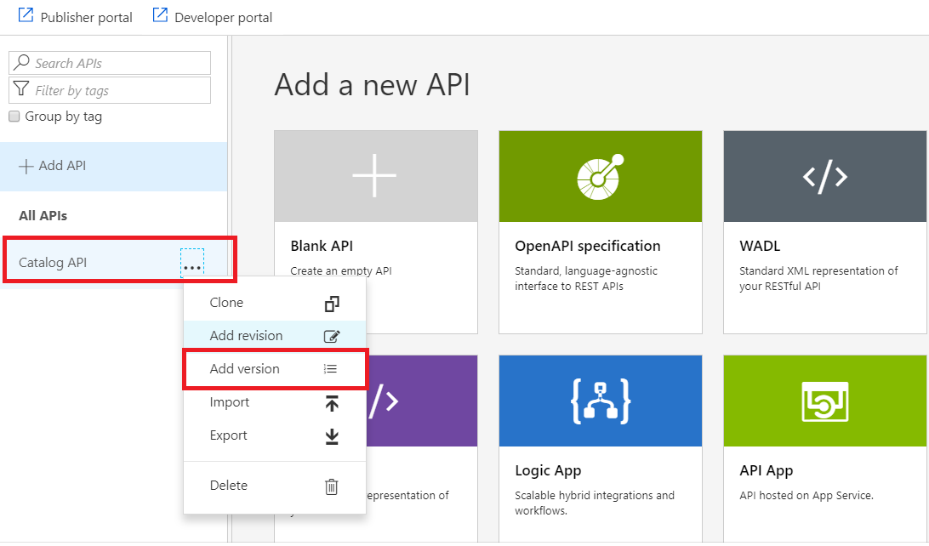

**Choose a versioning scheme**

Azure API Management allows you to choose the way in which you allow callers to specify which version of your API they want. You specify which API version to use by selecting a versioning scheme. This scheme can be either path, header or query string. In the following example, path is used to select the versioning scheme.

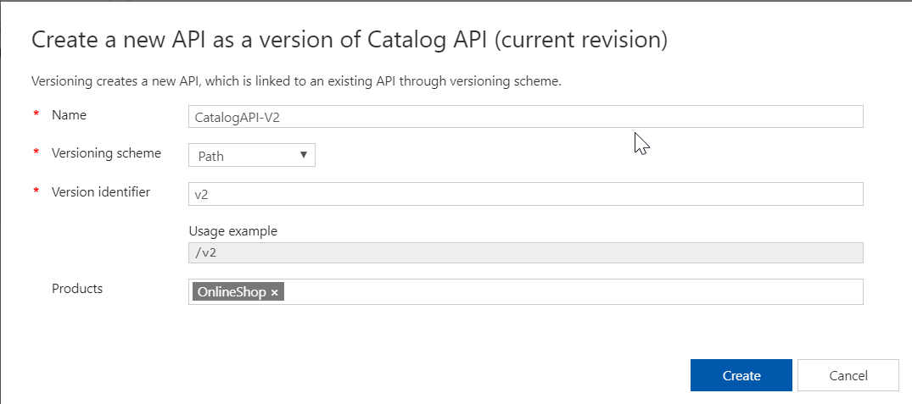

1. Leave path selected as your versioning scheme.
2. Type CatalogAPI-v2 in the Name field.
3. Type v1 in the Version identifier field.
4. Select Create to set up your new version.
5. Underneath Catalog API in the API List, you now see two distinct APIs - Original, and v2.

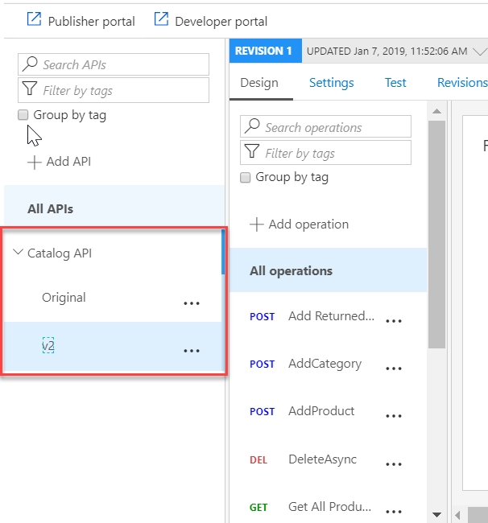

1. You can now edit and configure v1 as an API that is separate to Original. Changes to one version do not affect another.

**Add the version to a product**

In order for callers to see the new version, it must be added to a product.